Chapter 5 Preliminary questions

Type out your own personal answers to the following questions! Keep a folder of all the work you accomplish during this period.

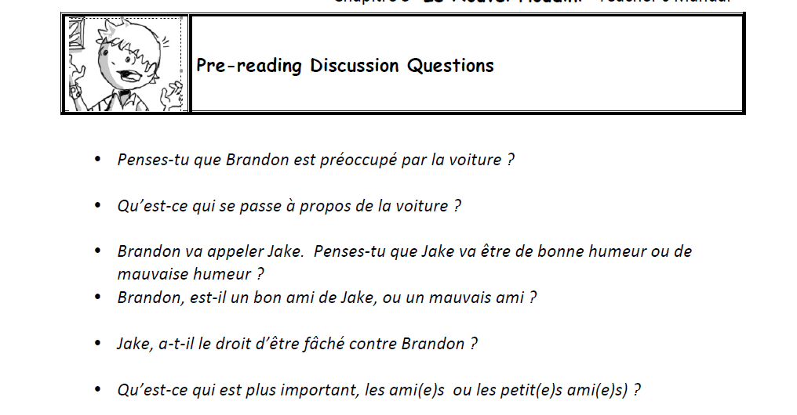

1.

2.

3

4

5.

6.

Chapter 5 Questions (Answer in English)

1. What problem does Brandon need to resolve?
2. Whom does Brandon call to help solve this problem?
3. Why Jake is mad?
4. Why does Brandon’s grandmother call to him?
5. What suggestion does Jake give about cleaning up the ketchup?
6. What excuse does Brandon give for needing vinegar?
7. What two odors exist now in the car?
8. What does Jake suggest, in order to solve this problem?
9. How much does this service cost?

FYI more questions

Chapter 5 Questions (Answer in French)

